Co-Chair  Vernon Sykes, Representative  34th House District | 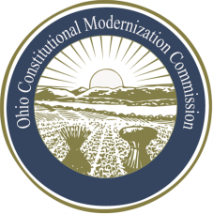 | Co-Chair  William G. Batchelder, Speaker  69th House District
Ohio Constitutional Modernization Commission

Legislative & Executive Committee
Fred Mills, Chair
Wednesday, July 10, 2013

Chairman Mills called the meeting of the Ohio Constitutional Modernization Commission, Legislative and Executive Committee to order at 11:30 a.m. A quorum was present. The minutes from the previous meeting were read and approved.

The Chairman introduced Professor Emeritus at Ohio State University, Paul A. Beck, Professor of History and Law at Ohio State University, David Stebenne, and Director of Election Law for Moritz College of Law, Edward B. Foley.

The professors each gave presentations before the members committee regarding the history and future concerns of reapportionment and redistricting in the state of Ohio.

Professor Beck discussed his concerns as well as the effects of gerrymandering regarding elections.

Professor Stebenne presented an article he had written and distributed it to the committee. He emphasized that there is no “gold standard” regarding redistricting. He recommended modifications to the 7 member reapportionment board.

Professor Foley emphasized that the committee take a long term approach to changes made regarding reapportionment and redistricting. He made recommendations, as to changes that could be made to the 7 member reapportionment board as well as suggested that the current “Ohio plan” be looked at, not only for modification but complete replacement, and institution of a new singular body.

Questions from the committee’s members regarded specific details of the different plans laid out by the professors.

With no further business before the committee, Chairman Mills adjourned at approximately 2:50 P.M.

